Create a blank document in Microsoft FrontPage and save it in the same folder as your existing web site. Call this file “feedback”. Format the new document so that it looks like the other pages in your web site (i.e., it has the same background and general layout).

(1) | From the “Insert” menu, select “Form”, then “Form” again. | 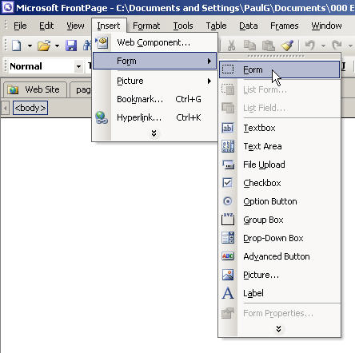

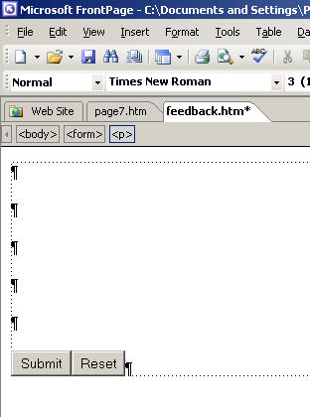 | (2) | A box will appear on the page, with two buttons at the bottom – [Submit] and [Reset].  Position the cursor to the left of the [Submit] button and press enter or return a few times; in order to expand the box and provide space above the buttons.

(3) | Now insert a table to help you lay out the different items on the form.  Go to the “Table” menu and select the “Insert” item. | 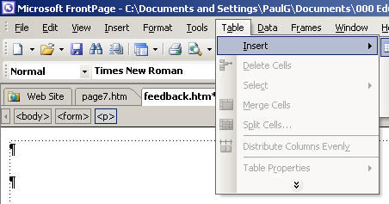

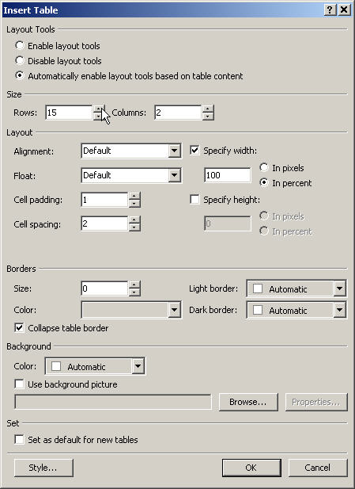 | (4) | From the box which appears, select the number of rows and columns you want.  If you don’t know how many of either you want at this stage, a good step would be to draw up some designs for your form, prior to beginning its creation.  In this example, the table has been given 15 (fifteen) rows and 2 (two) columns.  In addition, the borders surrounding the table, have been reduced to nothing by adjusting the following setting…  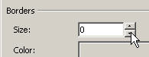

(5) | This example illustrates a method for creating table with some very narrow columns. These allow the arrangement of groups of small “option buttons” or “check boxes”.  To set these up, select the cells where the buttons are to be placed, then go to the “Table” menu and select “Split Cells…”.  This will help you split the selected cells into more columns or rows, depending on what you choose at the next step… | 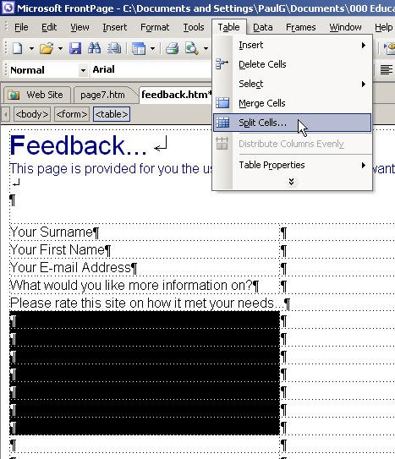

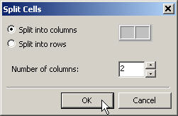 | (6) | In this dialog box, select whether you want to make more rows or more columns.  This example splits the selected cells into two columns per cell.

(7) | Each of the columns can then be set to their desired width.  This can be done by moving the cursor over the vertical border of a cell until the cursor becomes a double-headed arrow.  The width of the cell can be selected by left-clicking the vertical line at the side of the cell (the border), and holding the mouse button down whilst dragging the line to the desired width. | 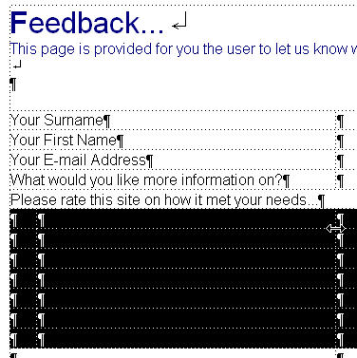

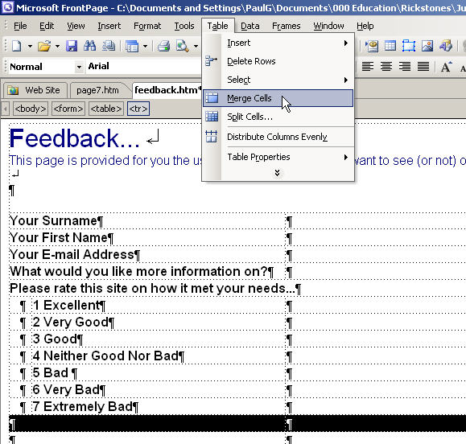 | (8) | In this example, some parts of the table need less columns rather than more (the 4th and 13th rows for example).  In order to reduce the number of columns in a row you can merge two or more cells into one.  To do this, select the cells you wish to merge, then go to the “Table” menu and select “Merge Cells”.  Once the table has been formatted appropriately, form fields can be inserted.

(9) | The first form field to be inserted is a field for the surname.  This field, the first name field and the e-mail field will all be textbox fields.  To insert a textbox, place the cursor where you want the textbox to go, then open the “Insert” menu and select “Form”, then “Textbox”. | 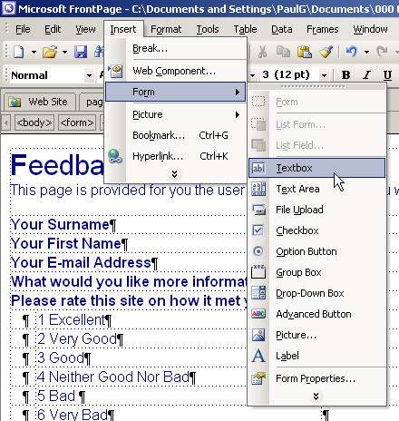

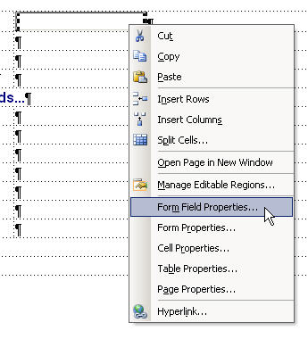 | (10) | The textbox will be inserted and requires properties to be set for it.  To set the properties for the form field, right-click the text box and select “Form Field Properties…” from the menu which appears.  This will be the same procedure for each of the textboxes used in this example.

(11) | In the “Text Box Properties” dialog box, give the field a name. Usually this is the name of the field (i.e., for this example, the name is Surname). When the name contains more than one word, do not use spaces.  The width of the field in characters (e.g., number of letters and/or numbers) should be specified – be generous! | 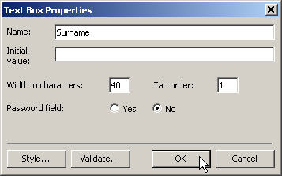
(11) |  | Lastly, the “Tab order” should be specified. This is the order in which the user will move to a given field when they push the Tab key.  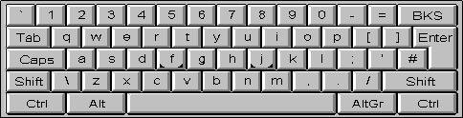  The example above shows that this field will be the first one a user will go to when they push the tab key.
 | Textbox fields should be entered for the First Name and E-Mail fields, these should also be given widths of 40 characters and tab orders of 2 (for First name) and 3 (for E-mail).

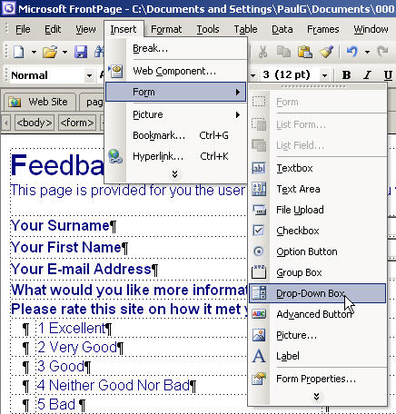 | (12) | The next field to enter offers a choice of options for the user via a “drop-down menu”.  Click on the “Insert” menu and select “Form”, then choose “Drop-Down Box”.

(13) | Once again, give the field a name, in this example – Information.  The choices the user will see now have to be added. To do this, click on the [Add…] button. | 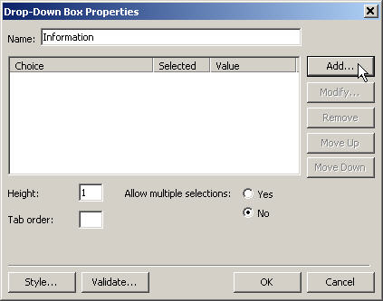

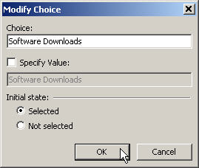 | (14) | The choice offered to the user is the text which is now entered into the “Choice:” field.  In this example, users will be able to choose “Software Downloads”.  The status of the “Initial state:” option button is “Selected”. This means that the value the user will see, before they make a selection, will be the “Software Downloads” choice (also known as the default value).  Once all options have been set, click on the [OK] button.

(15) | Each choice is added in the same manner and its “initial state” is indicated in the main “Drop-Down Box Properties” dialog box.  Next, set the tab order for the drop-down box.  Finally, make certain that the option button marked “Allow multiple selections:” is set to “No” – multiple selections can really confuse things!  Then click on the [OK] button. | 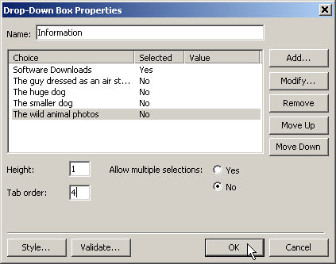

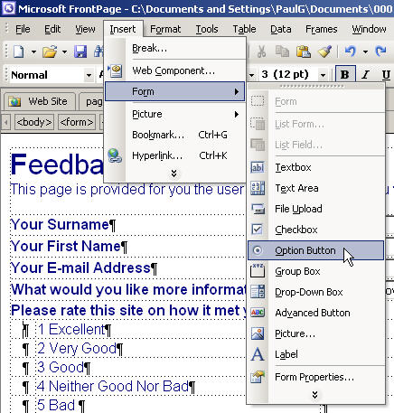 | (16) | The next set of fields are a group of option buttons for rating the site.  Go to the “Insert” menu and select “Form”, then choose “Option Button”.  When the option button has been placed in the web page, right-click the button and select “Form Field Properties…” from the menu which appears – see step (10) previously.

(17) | In the “Group name:” box, enter a descriptive name for the group of option buttons to be created. This example shows a group name of “RateSite” (note – no spaces between the words).  For the first button (only), mark its “initial state” as selected and set the tab order, then click on the [OK] button. | 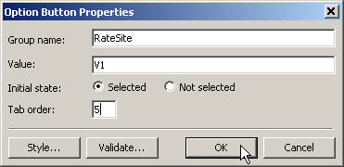

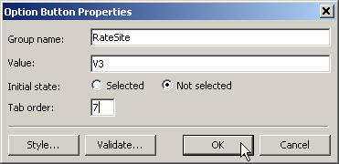  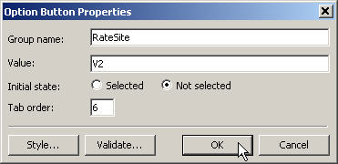  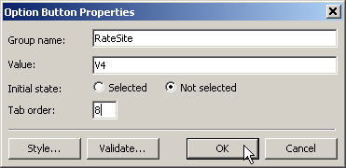  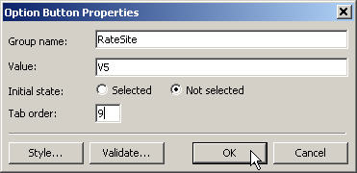  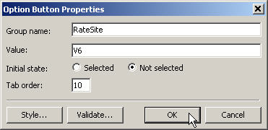  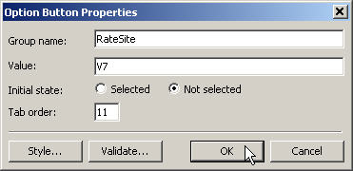 | (18) | Insert the other option buttons where required. Right-click each and set their properties in turn – make certain that each option button has exactly the same group name as the first.  Mark the initial state of each of the following buttons as “Not selected”.  Set the tab order for each button so that it follows from the last.

(19) | The last form field to be placed on the web page is an area for the user to enter text into for general comments – a text area field.  From the “Insert” menu, select “Form”, then choose “Text Area”. | 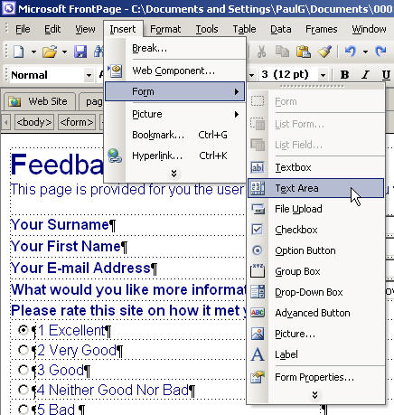

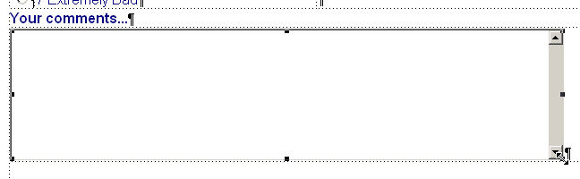 | (20) | Drag the text area box out to the size you prefer (see step 7 earlier for a guide to this function).  When the text area box has been arranged appropriately, right-click the box and select “Form Field Properties…” from the menu which appears – see steps (10) and (16) previously.

(21) | Set the form field properties for this field as previously (from the right-click menu).  Give the field a name and – for this field, enter some text in the “Initial value:” box. This is text which will be displayed to the user before they enter anything into the box (e.g., “Enter your comments here…”).  The size of the text area box is defined by its “width in characters” (83) and by the “number of lines” it displays (10).  The tab order should also be set to follow sequentially from the previous field.  When all settings have been completed, click on the [OK] button. | 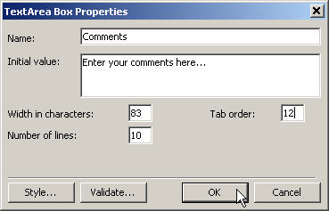

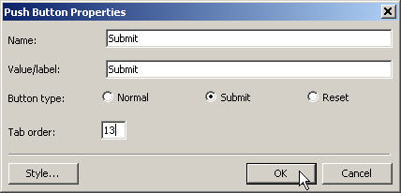  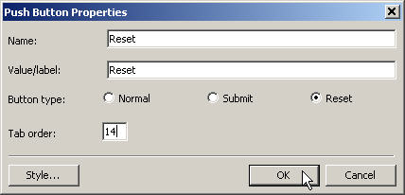 | (22) | Right-clicking the [Submit] button…  The button properties should be set as illustrated, i.e., “Name” = “Submit”, “Value/Label” = “Submit”, “Button type” should be set to “Submit” and the tab order set correctly.  The properties of the [Reset] button…  Should be set in the same manner, albeit with differing points…  The button properties should be set as “Name” = “Reset”, “Value/Label” = “Reset”, “Button type” should be set to “Reset” and the tab order set to follow on from the [Submit] button.

After setting properties for each of the form fields, properties for the entire form may be set in a similar manner…

(23) | Right-clicking anywhere in a blank area of the web page, will call up the following menu…  Select “Form Properties…” from the menu which appears. | 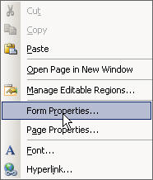

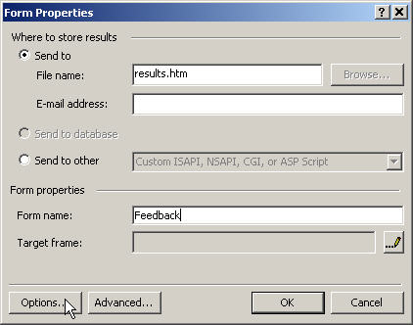 | (24) | In the dialog box which appears, the destination of the feedback questionnaire can be selected.  “Send to”…  “File name:” specify the name of a file to where the results can be saved.  “E-mail address:” specify the e-mail address to where the results can be sent.  In addition, a “form name” can be assigned to the form.  Further properties can be set via the [Options…] or [Advanced…] buttons.

(25) | The “File Results” tab (accessed via the [Options] button), accepts further information about outputting the web page results to a file (this file should be based on the web site). | 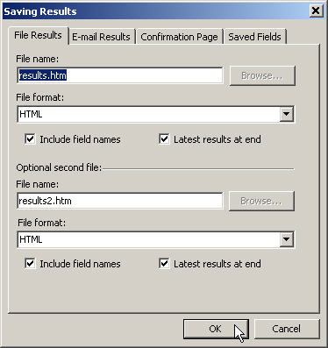

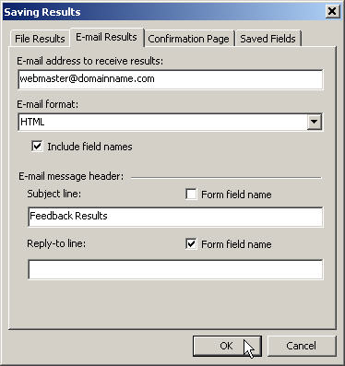 | (26) | The “E-mail Results” tab (accessed via the [Options] button), accepts further information about sending the web page results to a specified e-mail address.  Note: Steps (24) to (26) inclusive will not work if the server upon which a web site is hosted id not running Microsoft FrontPage “extensions” (special services designed to allow FrontPage web sites to offer many advanced features such as those discussed here).

(25) | Lastly, the “Confirmation Page” tab can be set to display a web page (created by yourself, for this purpose), which states that the form has been submitted successfully, for example…  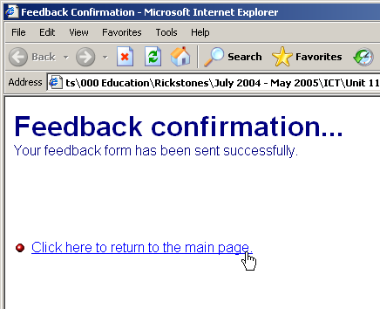 | 

